**Assignment 10**

Case study of any one social media analytics tool. (Cyfe)

**Author:**

Name: Sakshi Tantak

Class: TE-9

Roll No: 33156

Batch: M9

**Introduction**:

Business intelligence platform helps businesses of all sizes with KPI monitoring, search engine optimization, scheduling, social media marketing, custom reports, data export & archiving and more.

**Product Details:**

Cyfe is the ultimate business intelligence tool for creating custom dashboards and visualizing all of your business' data in one, powerful platform.

**Purpose**:

By planning ahead you can ensure you post the type of content necessary to reach your goals and grow your business.

A social media management tool will allow you to schedule social media posts ahead of time.

This will make it much easier to visualize what you will be posting and align it with your goals

### Overview of Cyfe Features:

* Automatic email reports
* Branded reports for clients
* Business KPIs
* Custom data sources
* Custom domains and logos
* Custom visualizations
* Easily monitor everything
* Historical data
* Monitor individual departments
* Multiple sharing options
* PDF/CSV exports
* Pre-built integrations
* Push API
* Real-time reports
* Setup in seconds
* Social media analytics
* Track multiple websites
* TV mode
* Unlimited users and dashboards
* White labeling available

### Technical details:

**Devices Supported**

* Windows
* Linux
* Android
* iPhone/iPad
* Mac
* Web-based
* Windows Mobile

**Deployment**

* Cloud Hosted
* Open API

**Language Support**

* English

**Pricing Model**

* Monthly payment
* Annual Subscription

**Customer Types**

* Small Business
* Large Enterprises
* Medium Business
* Freelancers

##### **Pros:**

* Integrates with almost every site/service
* The accuracy and its stable performance.
* Cyfe is a great, flexible dashboard tool that is really low cost
* Simple to use Many supported social media types SEO and Ranking All in one place

**Cons:**

* Sometimes the connected apps disconnect and reports show up as empty

**Implementation:**

Using the Cyfe tool, I have successfully analyzed the PICT MUN page which was hosted on Facebook. The analysis includes the total reach of the posts, the viewers of the stories posted, number of clicks and the overall performance of the page.

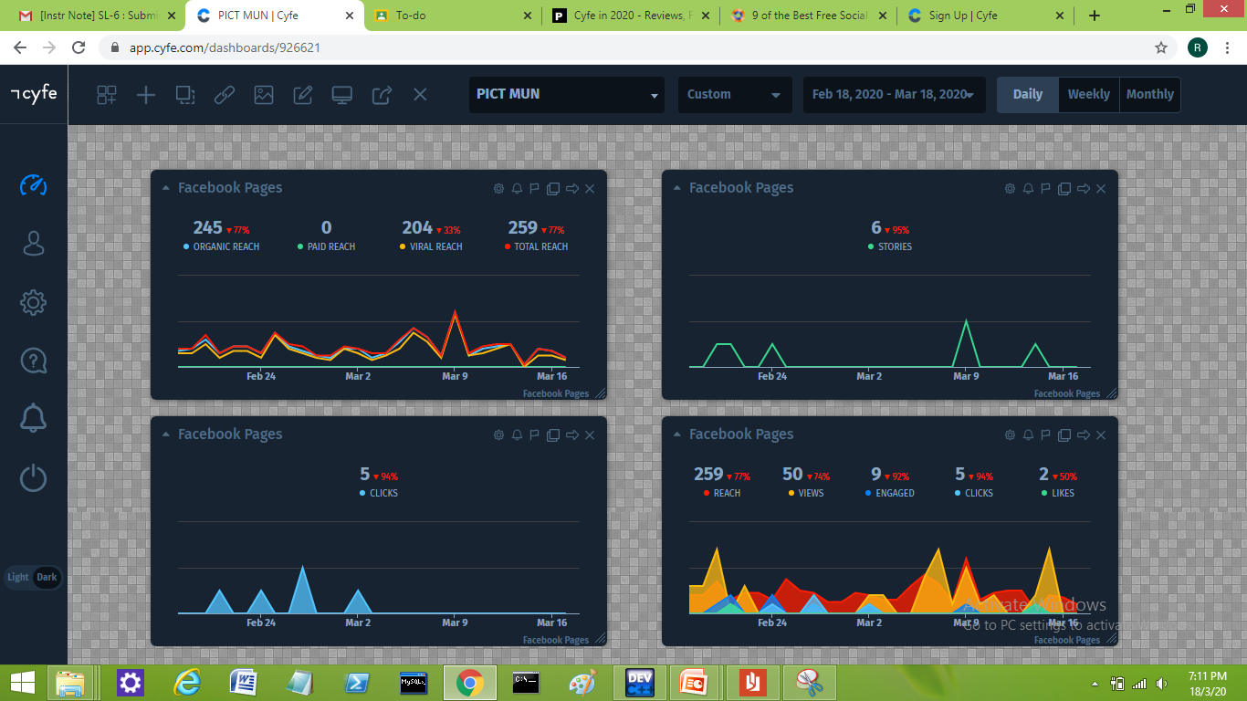

**Conclusion:** Thus the required social media analytics using social media analytics tool has been successfully carried out.